**NAAN MUDHALVAN**

SALESFORCE ASSIGNMENT

COLLEGE :**PSN INSTITUTE OF TECHNOLOGY AND SCIENCE**

NAME : JASMINE J

REG NO : 952420104010

NM ID : 0785B225EE2CFAA674401B41B7E5A08

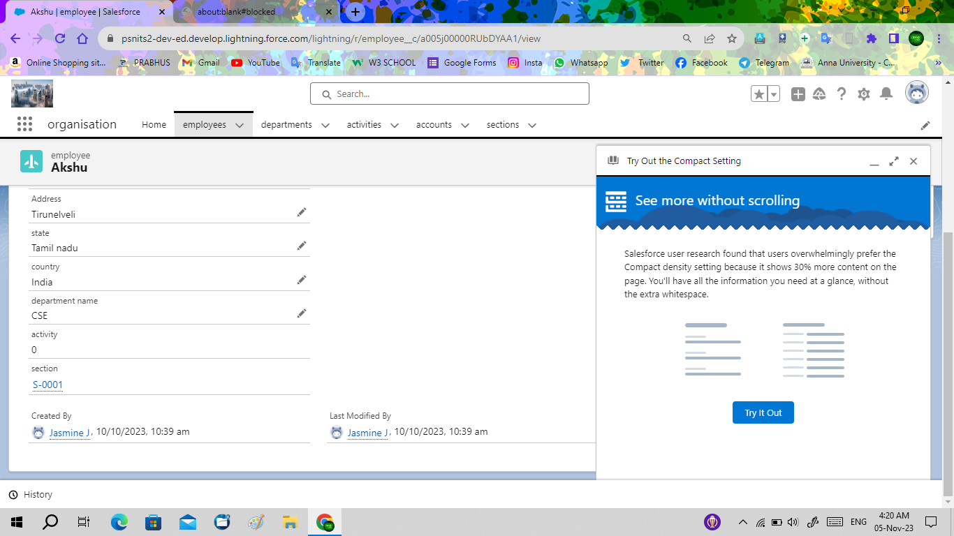**Task – 1 :**

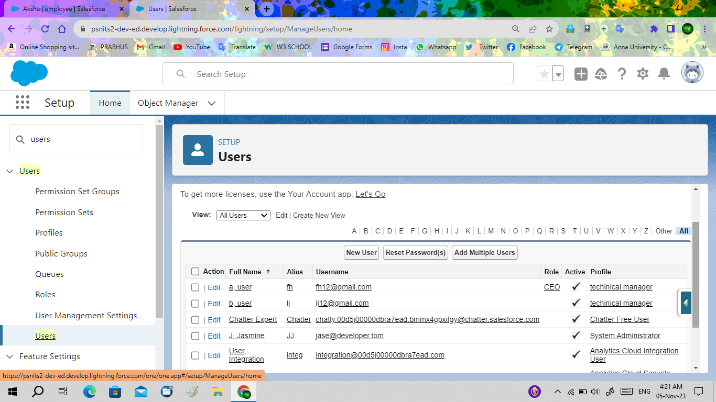**Task – 2 :**

**Task – 3 :**

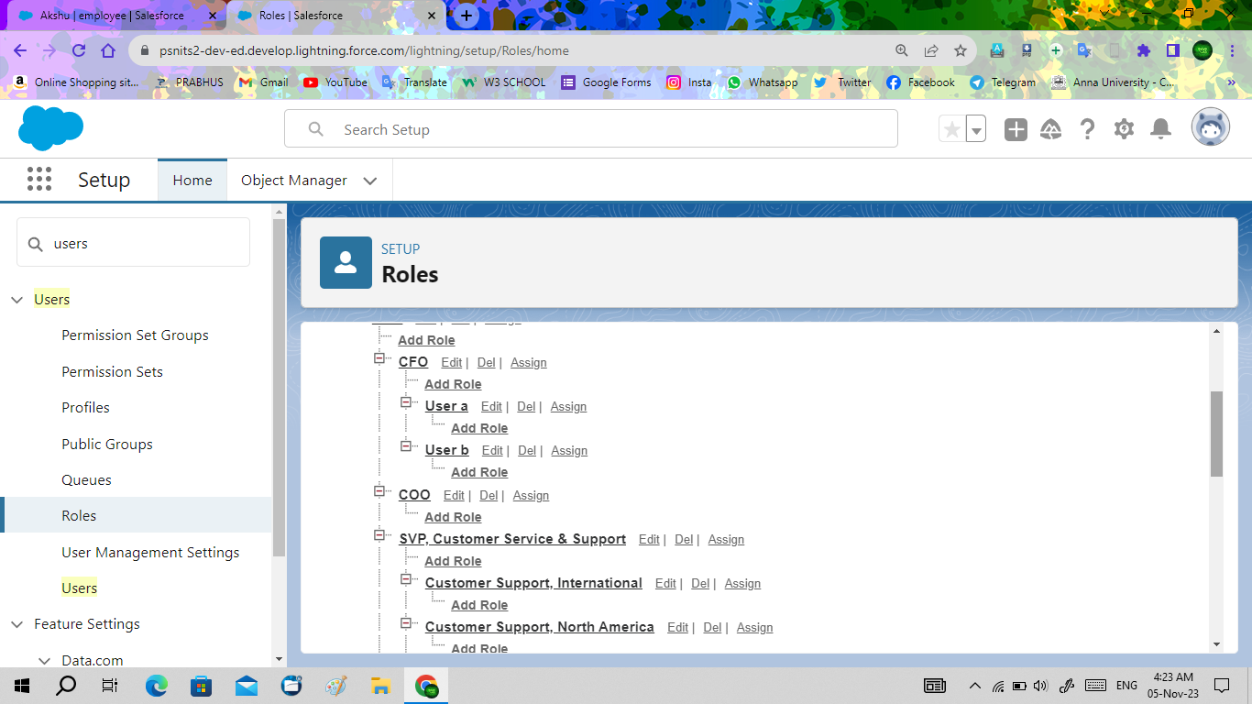

**Task – 4 :**

